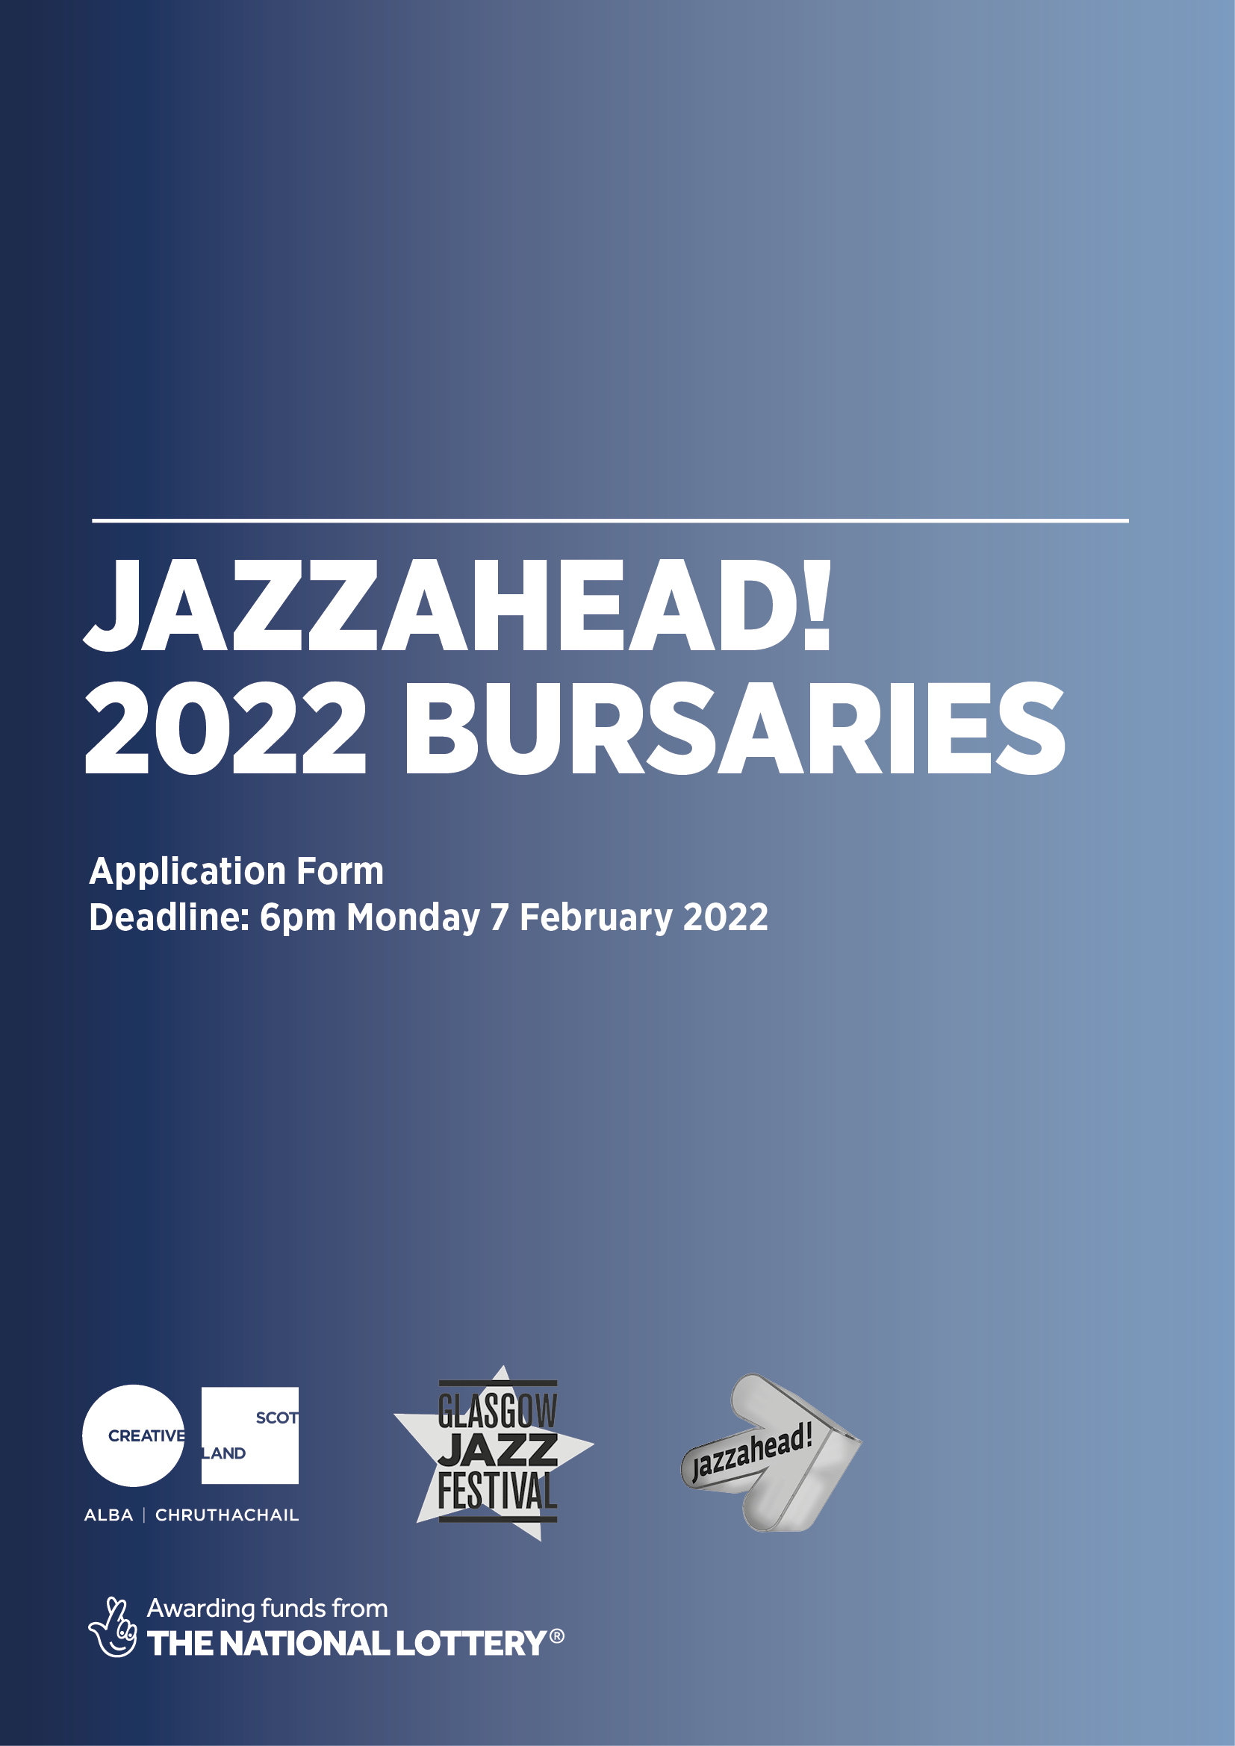

APPLICATION FORM FOR BURSARIES TO ATTEND
JAZZAHEAD! 2022 (28 APRIL – 1 MAY 2022)
DEADLINE: 6pm Monday 7 February 2022
Please ensure you have read the guidelines for this programme before you complete this form. These are available to view from the Glasgow Jazz Festival website here:
www.jazzfest.co.uk/jazzahead-2022-bursaries

It is a condition of funding that all bursary delegates:
- Commit to attending jazzahead! 2022 either digitally or in person, depending on the type of bursary they are awarded.
- Participate in an online pre-event briefing session with other delegates before the event. This is likely to take place in March 2022.
- Create their own promotional material for use at the event.
- Provide feedback after the event as requested, including in an online post-event meeting. Your feedback forms part of the evaluation for funders. This is likely to take place in June 2022.
It is a condition of funding that in-person bursary delegates:
- Remain aware of and comply with all COVID-19 regulations in Germany, Scotland and any other countries they may transit through when attending jazzahead!. In the event that regulations or personal circumstances do not allow travel, in-person delegates will be able to attend jazzahead! digitally instead.
- Have a valid passport and travel insurance at the time of the visit.
PLEASE ANSWER ALL QUESTIONS
I acknowledge that I have read and understood the application guidelines and confirm I agree to the conditions if successful in my application. | YES / NO *delete as appropriate
The information you provide in your application will be processed in accordance with Glasgow Jazz Festival’s Privacy Policy. Your application will be shared with the panel making the bursary selection decisions.
I agree for this application form to be shared with the jazzahead! bursary selection panel. | YES / NO *delete as appropriate
1. YOUR DETAILS
Name:

Name of ensemble(s) or band(s):

Residential address:

Postcode:

Telephone number:

Email address:

Website:

I am applying as: *delete as appropriate
Someone who is attending jazzahead! for the first time (whether online or in person)
Someone who has attended jazzahead! in the past (whether online or in person)
I am applying to be considered for the following type(s) of bursary (you may select one or both):
Digital attendance
In-person attendance
I am available to be involved with jazzahead! 2022 digitally or in person on the following dates *select all that apply:
Wednesday 27 April 2022
(only if applying to attend in person)
Thursday 28 April 2022
Friday 29 April 2022
Saturday 30 April 2022
Sunday 1 May 2022
Monday 2 May 2022
(only if applying to attend in person)
I am applying as: *delete as appropriate
Someone who is not a full-time student
Someone who is a part-time student – please provide evidence that your student status is part-time and that involvement in jazzahead! does not contribute to your academic studies.
ACCESS REQUIREMENTS
If you have any access requirements that would enable you to take part in jazzahead! if selected for a bursary, please include them here. Please speak to us if you need any help with working out what to include in this.
If you know what costs might be involved, please include them here. We have budgeted for access costs for those who require them, and the answer you give here will not have any effect on our decision to award a bursary.

2. YOUR WORK
We are looking to provide bursaries to artists (or their representatives) whose work is high-quality, innovative, rooted in the jazz music genre and is suitable for the jazzahead! market.
Tell us about your work and why you consider it appropriate for jazzahead! (300 words max).

Please provide three examples of your work that best demonstrate quality, innovation and suitability for the jazzahead! market. These can be in video and/or audio format. (You can either provide links, or email separate files. If you email the files separately, please write 'YES' under Files Attached, below)

Links:

Files Attached: YES / NO *delete as appropriate

Please note: We recommend you consult the attendee list on the jazzahead! website to get an understanding of which organisations and individuals attend the event (https://jazzahead.de/en/tradefair/#attendeelist), and to explore the content of the 2021 event (https://jazzahead.de/compact/).

3. YOUR TRACK RECORD
We are looking to provide bursaries to artists (or their representatives) who can demonstrate a committed track-record of working professionally in the Scottish jazz scene.
Please list your most significant performances, events, projects, achievements, awards, etc over the past four years. If applicable, please include any international performances.

4. INTERNATIONAL READINESS
We are looking to provide bursaries to artists (or their representatives) who can demonstrate that they and their work are export-ready (ie ready to tour, promote or export to an international market once restrictions allow for this).

Please give details of any recent or up-and-coming work which you feel demonstrates that you are export-ready (ie ready to tour, promote or export to an international market once restrictions allow for this).
(300 words max)

5. PROMOTIONAL ACTIVITY
We are looking to provide bursaries to artists (or their representatives) who can demonstrate that they will be able to clearly communicate, express and promote their work and practice to potential partners (eg promoters, labels, commissioners, collaborating artists).
Please provide links to your website, social media pages, newsletters, etc. If you have one, please also provide a link to your EPK (electronic press kit) or attach with your application.

6. CAREER RELEVANCE
We are looking to provide bursaries to artists (or their representatives) who can demonstrate that they have clear aims they want to achieve by attending jazzahead! 2022, and can convey why this point in their career is an appropriate time to do so.
Please outline why you are applying to attend jazzahead! 2022 and what you hope to achieve or gain by attending, digitally and/or in-person
Please tell us why this opportunity is relevant to your career ambitions and/or future plans
If you’ve been to jazzahead! before, whether online or in person, please tell us how you plan to use the 2022 event to build on your previous visits.
(500 words max)

7. SUSTAINABLE TRAVEL (only answer this question if you are applying to attend jazzahead! 2022 in person)
As part of our commitment to environmental sustainability, we are planning to prioritise travel via land and sea, using flights only pandemic or personal circumstances make this necessary. This will necessitate an extra day’s travel either side of jazzahead! 2022 (ie 27 April and 2 May). Are there any reasons why you are unable to undertake sustainable travel if you are awarded a bursary? This will not factor into decision-making, but helps us to plan and budget appropriately.

YES / NO *delete as appropriate

If you have any queries before submitting your application, please email jill@jazzfest.co.uk with ‘JAZZAHEAD! 2022’ in the subject line.
We offer access support to disabled applicants, tailored to individual requests. If you require any access support when making your application please email jill@jazzfest.co.uk with ‘JAZZAHEAD 2022 ACCESS SUPPORT’ in the subject line.
When complete, please email the form and any attachments, in one email, to jill@jazzfest.co.uk with ‘JAZZAHEAD! 2022’ in the subject line.
DEADLINE: 6PM on MONDAY 7 FEBRUARY 2022.

