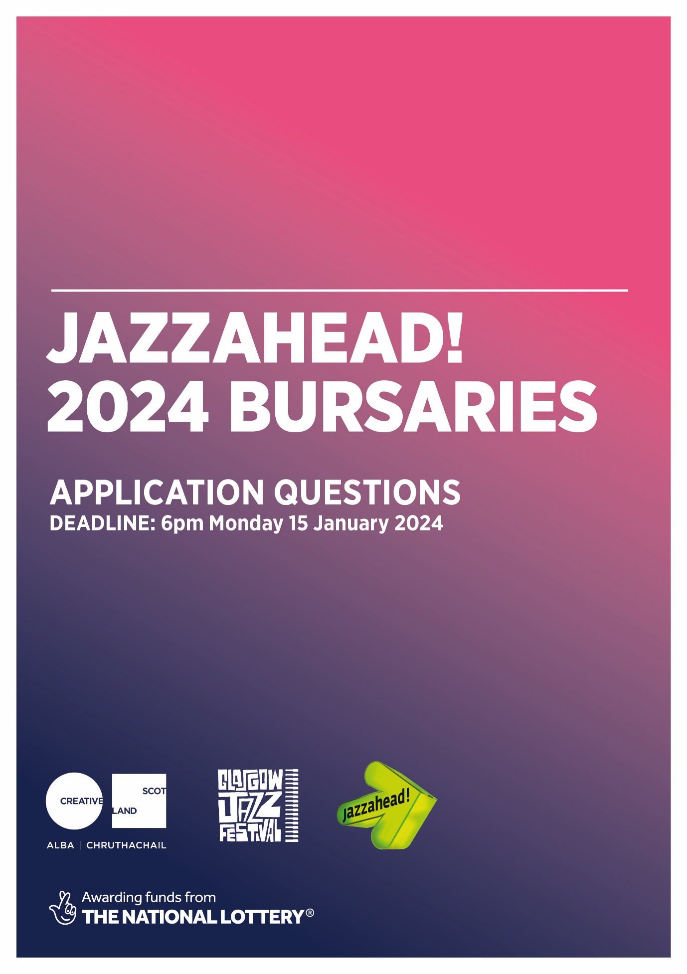
If you are applying using an audio or video clip, please read the bursary application guidance before applying. Then answer the following questions in your recording, and email the link of your recording to glasgow@jazzfest.co.uk, by 6pm on Monday 15 January 2024.
- Tell us your name and which band(s) you are planning to represent at jazzahead! 2024.
- Tell us about your work and why you consider it appropriate for jazzahead!.
- Tell us your most significant performances, events, projects, achievements, awards, etc over the past five years. If applicable, please include any international performances.
- Tell us about any recent or up-and-coming work or projects which you feel demonstrates that you are export-ready (ie ready to tour, promote or export to an international market).
- Tell us why you are applying to attend jazzahead! 2024 and what you hope to achieve or gain by attending.
- Tell us why this opportunity is relevant to your career ambitions and/or future plans.
- If you’ve been to jazzahead! before, whether online or in person, please tell us how you plan to use the 2024 event to build on your previous visits.
Please also provide the following information in your recording, or in the email you send it in with:
- Tell us:
  - your current address
  - your telephone number
  - your website address, EPK (electronic press kit) link, social media links, newsletters, etc.
  - whether or not you have any access requirements that we can support you with if your application is successful.
- Confirm that:
  - you have read and understood the application guidelines and that you agree to the requirements of all bursary holders if your application is successful
  - your application can be shared with the jazzahead! bursary selection panel
  - you are based in Scotland
  - you are available between Wednesday 10 and Sunday 14 April 2024 to attend and travel to and from jazzahead!
  - you are not a full-time student.

