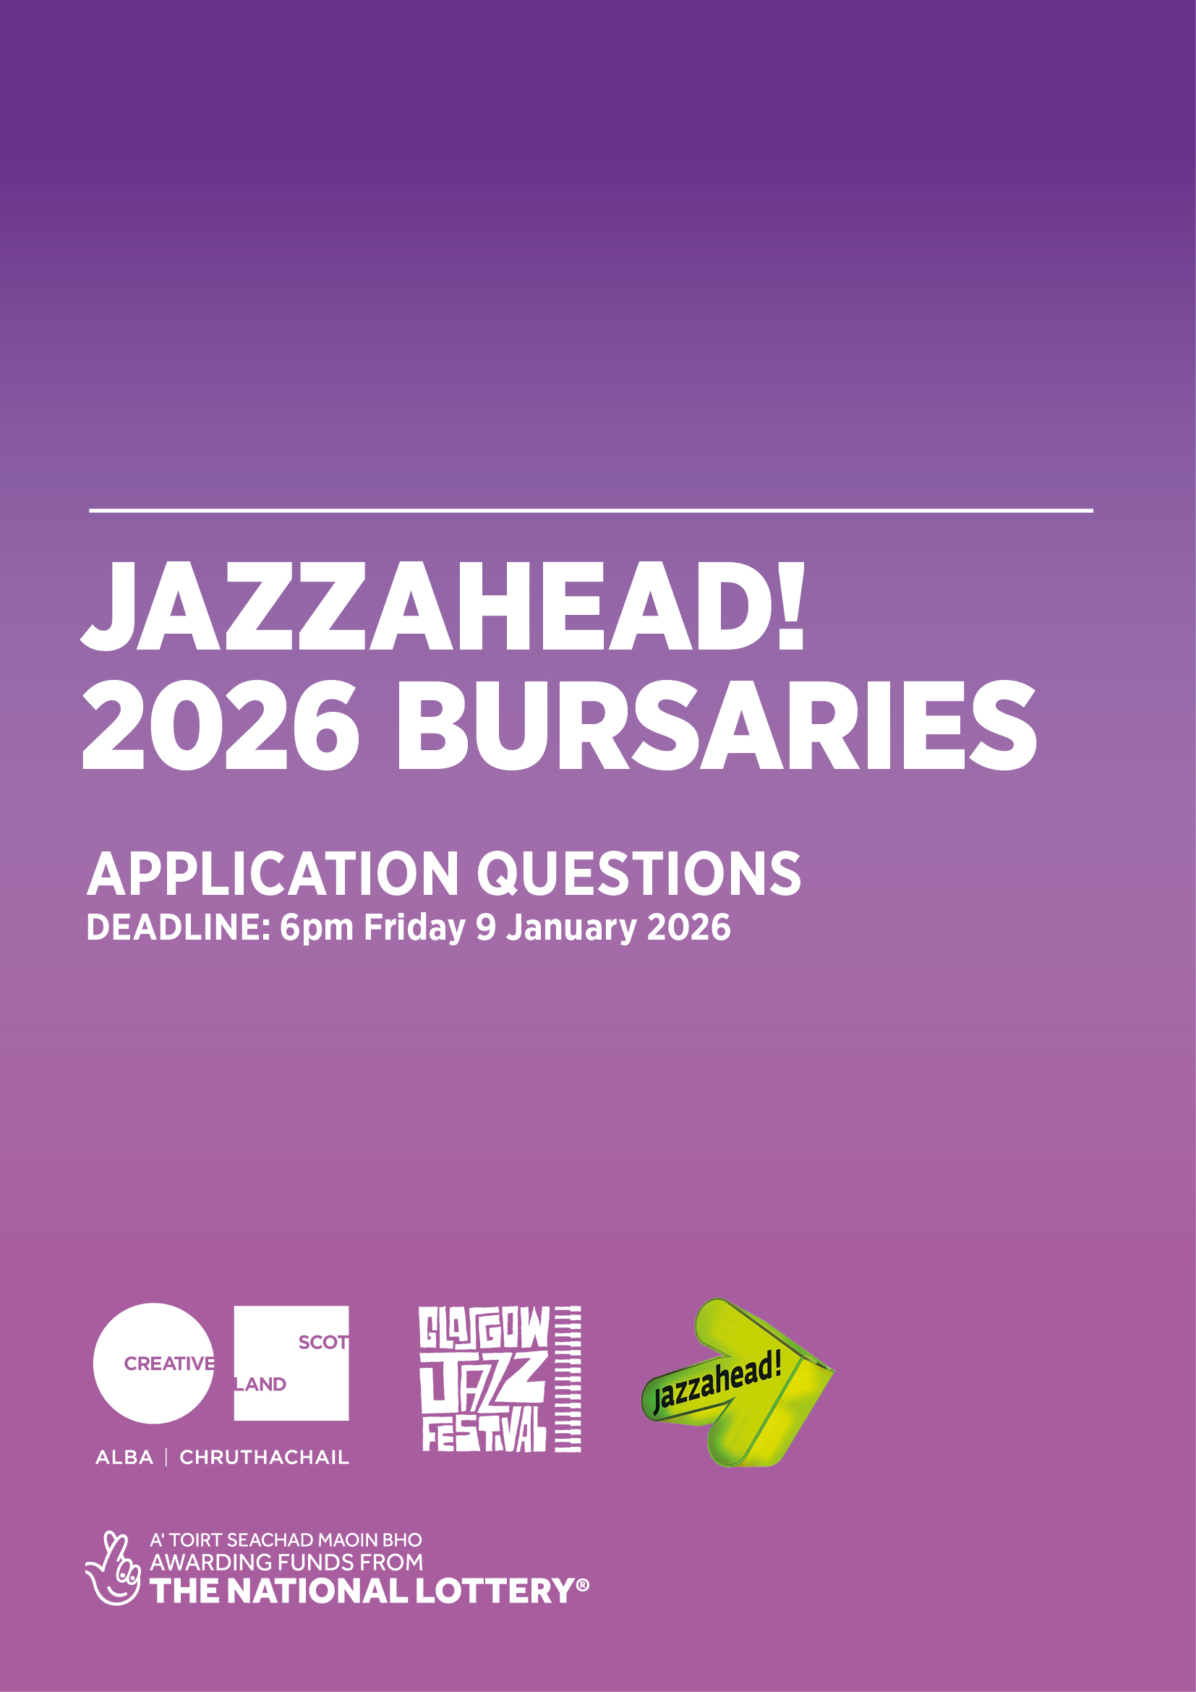

APPLICATION FORM FOR ARTIST BURSARIES TO ATTEND
JAZZAHEAD! 2026 (WEDNESDAY 22 – SATURDAY 25 APRIL 2026)
DEADLINE: 6pm on FRIDAY 9 JANUARY 2026

MAKING AN APPLICATION
You can apply by completing this form and emailing it to glasgow@jazzfest.co.uk by 6pm on Friday 9 January 2026.
Please ensure you have read the guidelines for this bursary programme before you submit your application. These are available on the Glasgow International Jazz Festival website.
ACCESS SUPPORT
If you require any access support when making your application, please contact glasgow@jazzfest.co.uk.
ADDITIONAL INFORMATION AND QUESTIONS
If you have any questions before submitting your application, please email glasgow@jazzfest.co.uk.
DATA PROTECTION
For information on how Glasgow International Jazz Festival will use your personal information, read our Privacy Policy.

ALL BURSARY DELEGATES ARE REQUIRED TO:

- Commit to attending jazzahead! 2026 in person for at least 2 full days of the 3-day event.
- Have a valid passport and travel insurance at the time of the visit.
- Participate in information sessions with other delegates before the event.
- Create their own promotional material for use at the event.
- Provide promotional material (biography, photograph, links to music and social media) to Creative Scotland.
- Prepare for the event using jazzahead!’s online resources.
- Provide feedback after the event as requested, including in a post-event meeting. This is likely to take place in May/June 2026.
We also invite all Artist Bursary delegates to staff the Scotland trade fair desk for at least one hour-long slot during the event to welcome delegates from other countries, answering their questions or sharing information about Scotland’s jazz scene. Artists who attended jazzahead! in the past say that it is a good way to meet other international delegates. Staffing the desk is optional and we will give you the information you need to do this in whatever way suits you best.

PLEASE ANSWER ALL QUESTIONS
STANDARD ELIGIBILITY CHECKS
I acknowledge that I have read and understood the application guidelines and confirm that I agree to the requirements if successful in my application.  (Delete as appropriate) | YES
 | NO
I confirm that I have read and understood Glasgow International Jazz Festival’s Privacy Policy.  (Delete as appropriate) | YES
 | NO
I confirm that I am based in Scotland.  Please note: all applicants must be based in Scotland to be eligible.  (Delete as appropriate) | YES
 | NO

PERSONAL DETAILS
Name
Name of ensemble(s) or bands(s), if relevant
Current address and postcode
Telephone number
Email address
I am applying as:  (Delete as appropriate) | Someone who is attending jazzahead! for the first time
I am applying as:  (Delete as appropriate) | Someone who has attended jazzahead! in the past
I am available to be involved with jazzahead! 2026 in person on the following dates:  (Select all that apply) | Wednesday 22 April 2026 (travel)
 | Thursday 23 April 2026
 | Friday 24 April 2026
 | Saturday 25 April 2026
Sunday 26 April 2026
(travel)
Full-time students are not eligible to apply for this bursary programme. I confirm that I am:  (Delete as appropriate) | Not a student
A part-time student
If you are a part-time student, please provide evidence that your student status is part-time and that involvement in jazzahead! does not contribute to your academic studies. This should be attached with your application and emailed to glasgow@jazzfest.co.uk

ACCESS REQUIREMENTS
Do you have any access requirements that would enable you to take part in jazzahead! 2026 if selected for a bursary?  The answer you give here will not have any effect on our decision to award a bursary. We have budgeted for access costs for those who require them and will discuss your needs with you if you are offered a bursary.  (Delete as appropriate) | YES
 | NO

JAZZAHEAD! ARTIST BURSARY – APPLICATION QUESTIONS
Tell us about your artistic work and why you consider it appropriate for the jazzahead! market
(300 words max)
We are looking to provide bursaries to artists whose work is of a high quality, innovative, rooted in the jazz or improvised music genre and is suitable for the jazzahead! market.
We recommend you explore the showcase videos from jazzahead! 2025 to see what kind of artistic work they prioritise.
Please provide links to three examples of your work that best demonstrate quality, innovation and suitability for the jazzahead! market. These can be in video and/or audio format.
List your most significant performances, events, projects, achievements, awards, etc over the past five years. If applicable, please include any international performances.
We are looking to provide bursaries to artists who can demonstrate a committed track-record of working professionally in the Scottish jazz scene.
Please detail any recent or upcoming work/projects which demonstrate that you are export-ready (i.e. ready to tour, promote or export to an international market)
(300 words max)
We are looking to provide bursaries to artists who can demonstrate that they and their work are ready to tour, promote or export to an international market. This could include things like having a specific project that is ready to be shared with international partners, having a good understanding of where your potential international audiences are (e.g. through interest already shown by artists or promoters outside Scotland or through streaming data), etc.
Please provide links to your website, social media, newsletters, etc. If you have an EPK (electronic press kit), please provide a link or attach it with your application.
We are looking to provide bursaries to artists who can demonstrate that they will be able to clearly communicate, express and promote their work and practice to potential partners (e.g. promoters, labels, commissioners, collaborating artists). Having a good online presence showing up-to-date information and materials that international promoters can easily access and use often helps to demonstrate this.
Please outline why you are applying to attend jazzahead! 2026, what you hope to achieve or gain by attending, and why this opportunity is relevant to your career ambitions and/or future plans.
If you’ve participated in jazzahead! before, please also tell us how you plan to use the 2026 event to build on your previous visits.
(500 words max)
We are looking to provide bursaries to artists who can demonstrate that they have clear aims they want to achieve by attending jazzahead! 2026, and can convey why this point in their career is an appropriate time to do so.

Please submit your completed application form to glasgow@jazzfest.co.uk by 6pm on Friday 9 January 2026.

